PROJECT REPORT

TEAM
- Gangineni Poojitha
- Manju R
- Nandhitha S
PROJECT TITLE: IoT-Based Pedestrian Zone Safety System
INDUSTRY VERTICAL: Smart Cities & Urban Mobility (Road Safety and Intelligent Transportation Systems)
PROJECT CATEGORY: IoT, Artificial Intelligence, and Computer Vision

ABSTRACT
Pedestrian-only zones in crowded urban areas often face unauthorized entry by two-wheelers, creating safety risks and reducing walkability. This project proposes an IoT-Based Pedestrian Zone Safety System that combines proximity sensing (ultrasonic/IR), camera-based object detection (YOLOv8), and automated access control (boom barrier/gate). When a vehicle is detected within a defined detection zone, the system triggers audible and visual warnings, commands the barrier to close, and logs the event to a cloud database (Firebase) for monitoring and audit. When a pedestrian is detected, the barrier remains open to ensure safe passage. The approach reduces dependence on continuous manual enforcement while enabling fast response and data-driven monitoring.

1. INTRODUCTION

1.1 BACKGROUND
Rapid urbanization has increased road density and mixed traffic conditions, often forcing pedestrians to share space with bicycles, scooters, and motorcycles. Cities respond by creating pedestrian-only corridors near markets, school zones, transit hubs, and heritage streets. However, enforcement is challenging: traffic police cannot continuously monitor every access point, and static signboards do not deter violations.

1.2 NEED FOR THE SYSTEM
Unauthorized vehicle entry can lead to:
- collisions and injuries
- panic and crowd stampede risk in dense areas
- accessibility barriers for children, older adults, and people with disabilities
- reduced public confidence in pedestrian corridors
A technology-assisted system that detects entry attempts in real time and supports controlled access can significantly improve safety.

1.3 OBJECTIVE
The objective is to design and prototype a system that:
- detects humans and vehicles near a pedestrian-zone entrance
- distinguishes vehicles from pedestrians
- prevents or discourages unauthorized vehicle entry
- alerts pedestrians and authorities
- stores logs for review and analysis

1.4 SCOPE
This documentation covers the problem, requirements, system design, hardware and software implementation, algorithmic workflow, data logging, testing plan, safety considerations, and future enhancements.

2. PROBLEM STATEMENT
In busy city environments, pedestrian-only zones face frequent unauthorized access by two-wheelers and other vehicles. Traditional enforcement methods are limited by human availability, reaction time, and operational costs. There is a need for an automated, reliable, and scalable solution that can detect violations instantly, warn nearby pedestrians, notify authorities, and physically prevent entry where appropriate.

3. PROPOSED SOLUTION OVERVIEW

3.1 SYSTEM CONCEPT
The system creates a “smart gate” for a pedestrian-only entry point:
- Sensors and a camera continuously monitor the entrance.
- A detection algorithm identifies whether the approaching object is a person or a vehicle.
- If a vehicle is detected, the controller triggers:
  - audible/visual alert
  - barrier actuation (gate/boom closes)
  - cloud logging + optional authority notification
- If a pedestrian is detected, the gate remains open and the event can be logged.

3.2 KEY FEATURES
- Real-time vehicle detection
- Differentiation between humans and vehicles
- Automatic barrier control
- Multi-channel alerts (buzzer, LED/OLED display, optional SMS/app)
- Cloud-based activity logging

4. LITERATURE / RELATED WORK
This section summarizes common approaches used in smart safety and access control systems:
- sensor-based intrusion detection using IR/ultrasonic
- RFID-based restricted access (authorized tags)
- computer vision for vehicle/human classification
- IoT cloud logging and dashboards
The proposed system combines low-cost sensors with camera-based detection to improve reliability under varying conditions.

5. SYSTEM REQUIREMENTS

5.1 FUNCTIONAL REQUIREMENTS
- Detect approaching objects in the entrance zone.
- Classify objects into “pedestrian” vs “vehicle” (bicycle/motorcycle/scooter).
- Estimate distance to the entrance/gate.
- Trigger barrier closure for vehicles.
- Keep barrier open for pedestrians.
- Display warning messages and trigger buzzer during violation.
- Log events to cloud with timestamp and class label.

5.2 NON-FUNCTIONAL REQUIREMENTS
- Low latency (near real-time response)
- Reliable operation in outdoor environments
- Low power / stable power supply
- Data integrity for logs
- Safe mechanical design to avoid harming pedestrians

6. SYSTEM ARCHITECTURE

6.1 HIGH-LEVEL ARCHITECTURE
Components:
- Input sensing: ultrasonic sensor, IR (obstacle) sensor, PIR sensor (optional), camera
- Edge inference (computer vision): YOLOv8 running on a laptop/PC or a Raspberry Pi (recommended for the prototype)
- Control unit (IoT controller): ESP32 (recommended) to read sensors, control the barrier actuator, and push logs via Wi-Fi
- Output/actuation: servo motor (or geared DC motor + driver) for the boom barrier/gate, buzzer, and an OLED/LED display
- Networking: Wi-Fi using the ESP32
- Cloud: Firebase Realtime Database / Firestore for event logging and monitoring
Note on ESP8266 vs ESP32: ESP32 is preferred because it has more GPIO, better performance, and supports camera modules more easily. ESP8266 can still be used for Wi-Fi + basic control if needed.

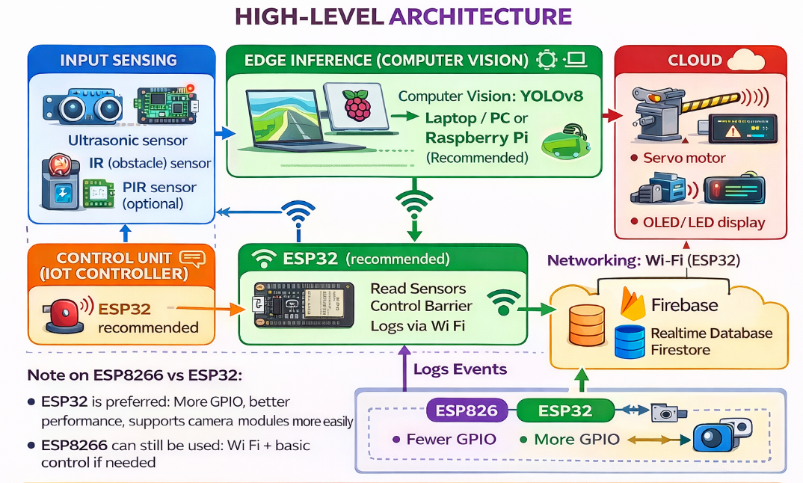

6.2 BLOCK DIAGRAM EXPLANATION

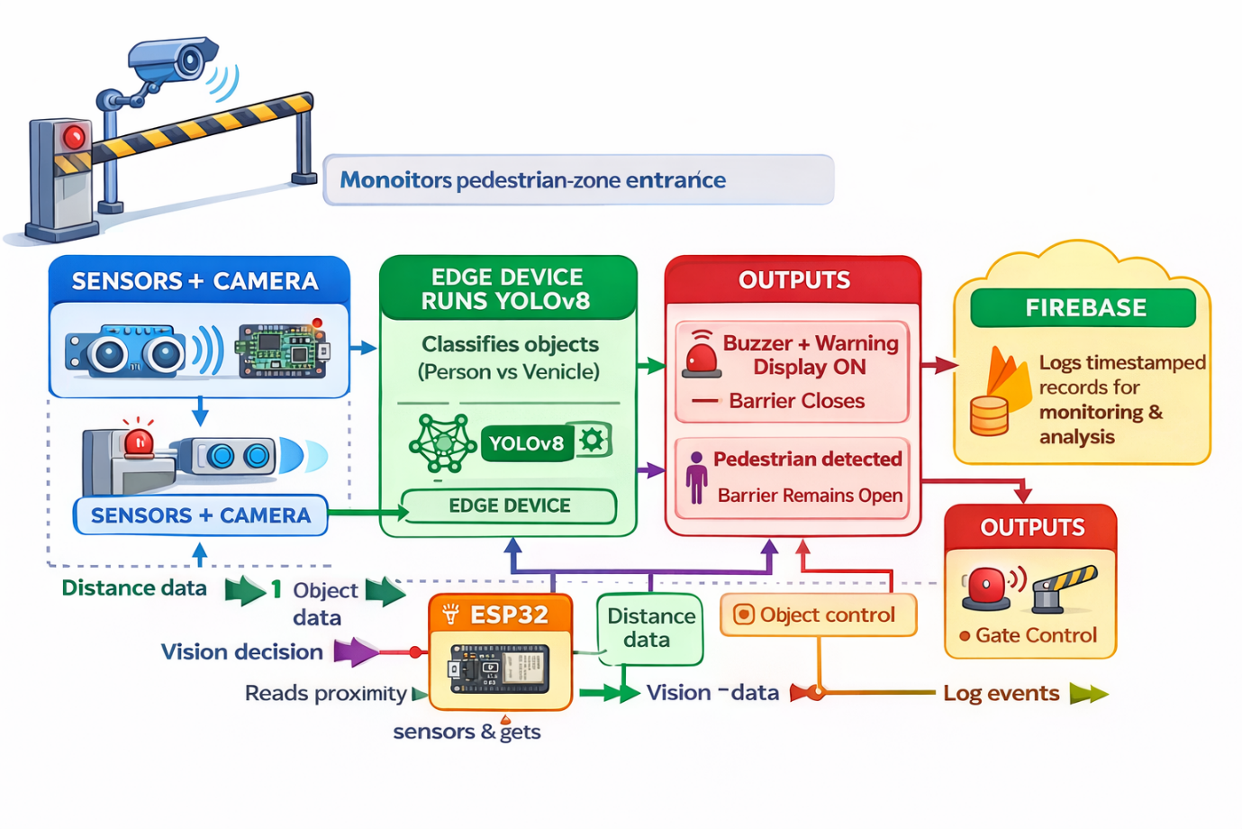

7. HARDWARE COMPONENTS

7.1 ULTRASONIC SENSOR (VEHICLE PROXIMITY)
Purpose: measures distance to detect an approaching object and estimate how close it is to the barrier.
- Example: HC-SR04 (prototype)
- Working principle: time-of-flight measurement of ultrasonic pulses

7.2 IR OBSTACLE SENSOR (BOUNDARY CONFIRMATION)
Purpose: confirms that an object has crossed a fixed boundary line (helps reduce false triggers).
- Useful as a secondary confirmation along with vision

7.3 PIR SENSOR (PEDESTRIAN MOTION — OPTIONAL)
Purpose: detects human motion near the entrance.
- Optional because YOLO already detects “person”, but PIR helps when visibility is low or the view is partially blocked

7.4 CAMERA (FOR YOLOV8 DETECTION)
Recommended options:
- USB/IP camera connected to a laptop/PC
- Raspberry Pi Camera + Raspberry Pi (for a compact edge setup)
(ESP32-CAM is possible for streaming, but running YOLOv8 inference directly on the ESP32 is not recommended for this prototype.)

7.5 CONTROL UNIT (ESP32 RECOMMENDED)
Purpose: reads sensors, drives the actuator, controls alerts, and sends logs over Wi-Fi.
- ESP32 is recommended for stability and feature support

7.6 ACTUATOR (BOOM BARRIER / GATE)
Purpose: physically blocks unauthorized vehicles.
- Prototype: servo motor for a small barrier
- Deployment: geared DC motor + limit switches (recommended for stronger gates)

7.7 ALERT DEVICES
- Buzzer: audible warning
- OLED/LED display: visual warning (example: “PEDESTRIAN ZONE — NO VEHICLES”)

7.8 POWER SUPPLY
- Provide separate, regulated supply for the actuator (servo/motor) and the controller to avoid resets
- Typical: 5V for sensors/servo (as required) and 3.3V logic for ESP32

Technologies / Frameworks Used
- Python – Core programming language for system development.
- YOLOv8 – Real-time object detection and classification of pedestrians and vehicles.
- OpenCV – Image processing and camera feed handling.
- ESP32 / Arduino – Microcontroller for sensor integration and gate control.
- Firebase Realtime Database – Cloud-based event logging and monitoring.
- IoT Sensors – Ultrasonic, IR, and PIR sensors for object detection and distance measurement.
- Wi-Fi Communication – Real-time data transfer between hardware and cloud services.
- Computer Vision – Vehicle and pedestrian recognition using AI models.

8. SOFTWARE COMPONENTS

8.1 YOLOV8 OBJECT DETECTION (PYTHON)
YOLOv8 is used to detect and classify objects in the camera frame.
- Classes of interest: person, bicycle, motorcycle (and optionally car)
- Output: bounding boxes + confidence scores

8.2 DISTANCE ESTIMATION LOGIC
Two approaches:
- Sensor-based distance (ultrasonic)
- Vision-based approximate distance using bounding-box size calibration
In this project, distance from the gate is calculated and used to trigger gate closure quickly for vehicles.

8.3 CLOUD LOGGING (FIREBASE)
Each detection/incident is stored with:
- timestamp
- object class (person/vehicle type)
- distance (if available)
- action taken (gate closed/open)

8.4 FIRMWARE FOR CONTROLLER
Responsibilities:
- read sensor inputs
- receive detection command from Python module (serial/Wi-Fi)
- drive servo/actuator
- activate buzzer/display

9. Method (Proposed Workflow)

9.1 WORKFLOW

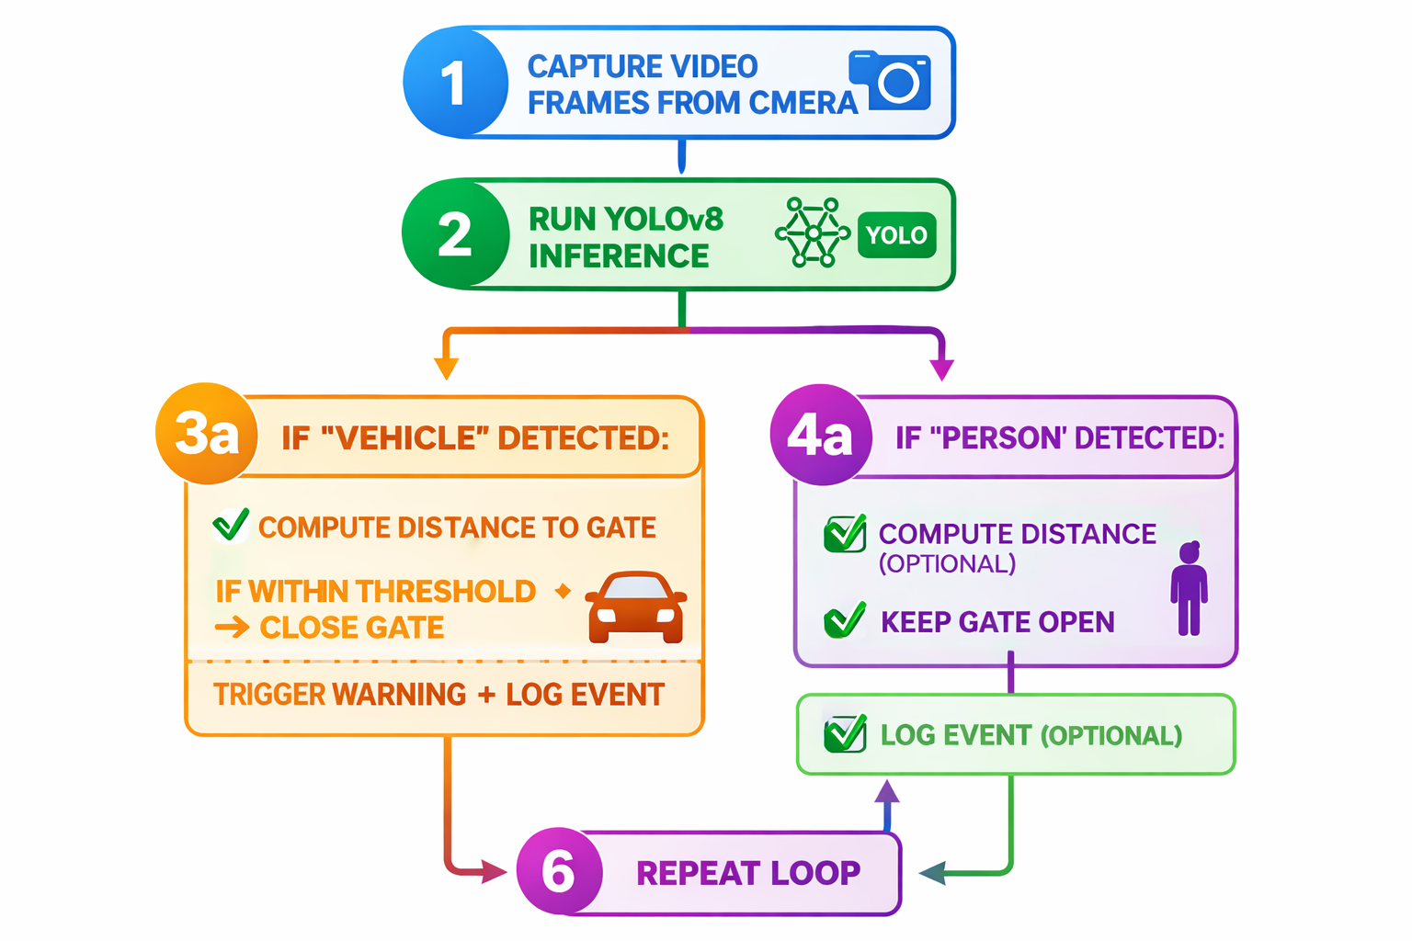

9.2 DECISION THRESHOLDS
Typical thresholds (example values for prototype; tune during testing):
- Vehicle distance threshold: 1.0–2.0 meters → close gate
- Cooldown time after closure: 3–5 seconds
- Confidence threshold for YOLO: 0.5–0.7

9.3 FALSE POSITIVE REDUCTION
- Combine vision detection with sensor confirmation (IR/ultrasonic)
- Use consecutive-frame confirmation (e.g., detect vehicle in 3 out of 5 frames)
- Maintain a minimum time gap between repeated triggers

10. COMMUNICATION & INTEGRATION

10.1 PYTHON-TO-CONTROLLER COMMUNICATION
Common options:
- Serial UART (USB) from PC to Arduino
- Wi-Fi UDP/HTTP/MQTT to ESP8266/ESP32

10.2 DATA FORMAT (EXAMPLE)
- Message: {type: vehicle/person, distance: x, action: close/open}

11. DATABASE DESIGN (FIREBASE)

11.1 SUGGESTED SCHEMA
- events/
  - event_id/
    - timestamp
    - label
    - confidence
    - distance
    - action
    - image_snapshot_url (optional)

11.2 DASHBOARD (OPTIONAL)
- Realtime list of recent events
- Counts by class per hour/day
- Violation trend visualization

12. PROTOTYPE DESIGN

12.1 PHYSICAL SETUP
- Gate/boom barrier at entrance
- Camera aligned to cover approach path
- Ultrasonic sensor placed to measure approach distance
- IR sensor positioned at boundary
- Display and buzzer visible/audible to pedestrians and riders

12.2 SAFETY NOTES FOR PHYSICAL BARRIER
- Barrier should not close aggressively
- Include a fail-safe open mode on power loss
- Provide visible signage and warning lights

13. IMPLEMENTATION PLAN

13.1 HARDWARE ASSEMBLY
- Mount sensors and camera
- Connect microcontroller pins and power
- Integrate servo motor and barrier mechanism

13.2 SOFTWARE SETUP
- Install Python and required libraries
- Configure YOLOv8 model
- Implement inference + decision logic
- Implement Firebase logging
- Implement controller firmware

14. TESTING & VALIDATION

14.1 TEST CASES
- Single pedestrian crossing
- Multiple pedestrians
- Bicycle approaching slowly
- Motorcycle approaching quickly
- Mixed pedestrian + vehicle scenario
- Low light condition
- Occlusion (crowd near camera)
- Network loss (Firebase unavailable)

14.2 Metrics
- detection accuracy (precision/recall)
- time-to-alert
- time-to-barrier-close
- false trigger rate
- log completeness

15. Results (Prototype Outcomes)
- Vehicle triggers closure within threshold distance
- Pedestrian passage remains unobstructed
- Alerts clearly visible/audible
- Events recorded reliably in cloud
15.1 Current State of the Project
The project has reached the functional prototype stage. A working model has been developed using YOLOv8 object detection, Python, ESP32/Arduino controller, sensors, and Firebase cloud database integration. The system is capable of detecting pedestrians and unauthorized vehicles in real time, automatically controlling the gate mechanism, generating alerts, and logging events to the cloud. Initial testing has been successfully conducted to validate vehicle detection, pedestrian recognition, automated gate operation, and real-time data storage. Further optimization and large-scale field testing are planned to enhance reliability and deployment readiness.
15.2 Efforts Invested Thus Far:
The team has invested significant effort in researching pedestrian safety challenges and identifying suitable technologies for an effective solution. Extensive work was carried out in designing the system architecture, selecting hardware components, and integrating sensors with the controller. The YOLOv8 object detection model was implemented and tested for accurate vehicle and pedestrian recognition. Firebase cloud integration was developed for real-time event logging and monitoring. Multiple prototype iterations, testing sessions, debugging activities, and performance evaluations were conducted to improve system reliability and responsiveness. The team also prepared technical documentation, presentations, and demonstrations to validate the project's feasibility and impact.

16. ADVANTAGES
- Improves pedestrian safety by preventing vehicle intrusion.
- Real-time alerts enable quick response by pedestrians and authorities.
- Reduces accidents in crowded areas using automated detection and control.
- Supports rule enforcement without continuous manual monitoring.
- Creates a pedestrian-friendly environment and improves urban walkability.

17. LIMITATIONS
- camera-based detection can be affected by lighting and weather
- mechanical barrier requires careful safety design
- network dependency for cloud logging (local buffering recommended)
- model performance depends on training and class coverage

18. SOCIAL IMPACT AND RELEVANCE
This solution supports safer, smarter cities by:
- reducing pedestrian injuries and near-misses
- improving compliance with pedestrian-zone rules
- enabling transparent logs for authorities
- promoting sustainable mobility and walkable streets

19. COST ESTIMATE (PROTOTYPE)
Typical prototype bill of materials includes:
- microcontroller (Arduino/ESP)
- sensors (ultrasonic, IR, PIR)
- camera module
- servo/actuator + gate materials
- display/buzzer
- power supply
(Insert local pricing and final totals.)

20. FUTURE ENHANCEMENTS
- automatic number plate recognition (ANPR) for violations
- SMS/WhatsApp notifications to authorities
- edge-only operation with offline logging + later sync
- solar power for outdoor deployment
- improved distance estimation and trajectory prediction
- multi-camera fusion for wider entrances

21. CONCLUSION
The IoT-Based Pedestrian Zone Safety System provides a practical approach to prevent unauthorized vehicle entry into pedestrian-only areas. By combining sensors, computer vision (YOLOv8), automated barrier control, and cloud logging, it reduces dependence on manual monitoring and increases real-time responsiveness. With further testing and safety-focused mechanical design, the system can be deployed to improve pedestrian well-being and urban mobility.

